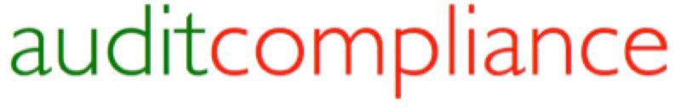

The first NEW and updated Office Procedures Manual (OPM) prepared for Lexcel 6.1 _{Dec} ₂₀₁₈, CQS CPMS _{May} ₂₀₁₉ and the New SRA Standards and Regulations and Solicitors Accounts Rules Nov 2019

- Designed for the new CQS Core Practice Management Standard required for all CQS firms to meet from 1 May 2019

- Incorporates all of the December 2018 changes GDPR etc for Lexcel 6.1 requirements

- Combines both the new SRA Standards and Regulations and SRA Solicitors Accounts Rules 2019

- Editable policies, procedures, documents, forms and links in easy to use Word format

- New up-to-date Policies for Transparency Rules 2018, AML, Privacy, GDPR and more

- Compliant and up-to-date with both the current SRA Handbook 2011 and SRA Account Rules, and also the New 2019 SRA Standards and Regulations and SRA Accounts Rules
Pricing Structure*

BASIC PACKAGE Per Annum Per Month
Office Procedures Manual 2 to 10 fee earners Subscription | £995 | £85
Office Procedures Manual Sole Practitioner Version (one Fee-Earner) | £695 | £60
ADDITIONAL COSTS
Office Procedures Manual 11 to 50 fee earners Subscription | £1495 | £125
Each Additional Office | £250 | £21
New CQS CPMS additional and updated Policies and Procedures (Only) | £250 | £21
* All prices are excluding VAT. Prices include customisation and compliance updates for one year.

Address: 11 Maresfield Road, Oakham, Rutland LE15 7FW Tel: 0203 290 5745 Email: paul.wilkinson@auditcompliance.co.uk

